### **Migration from On-Premises to Cloud Premises**

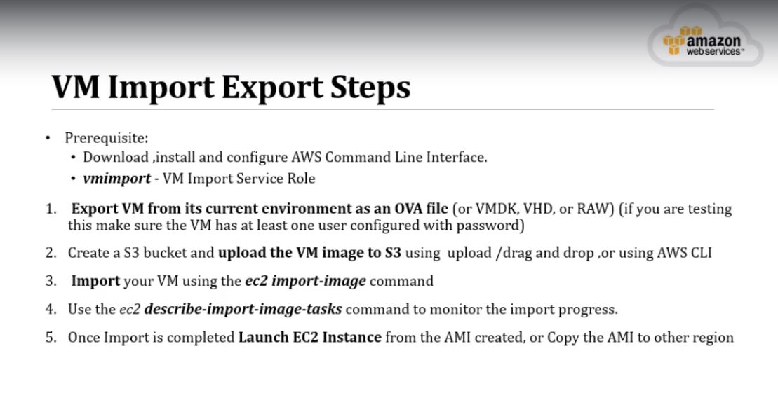

**Installing the AWS CLI**

<https://docs.aws.amazon.com/cli/latest/userguide/cli-chap-install.html>

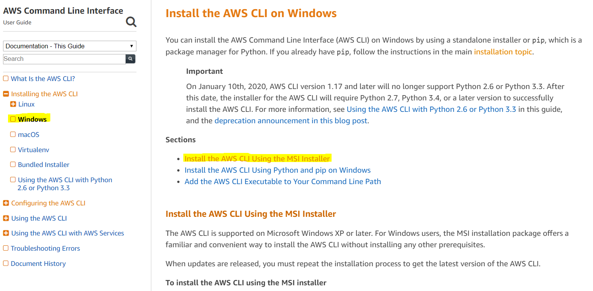

**Download the MSI installer for Windows (64-bit)**

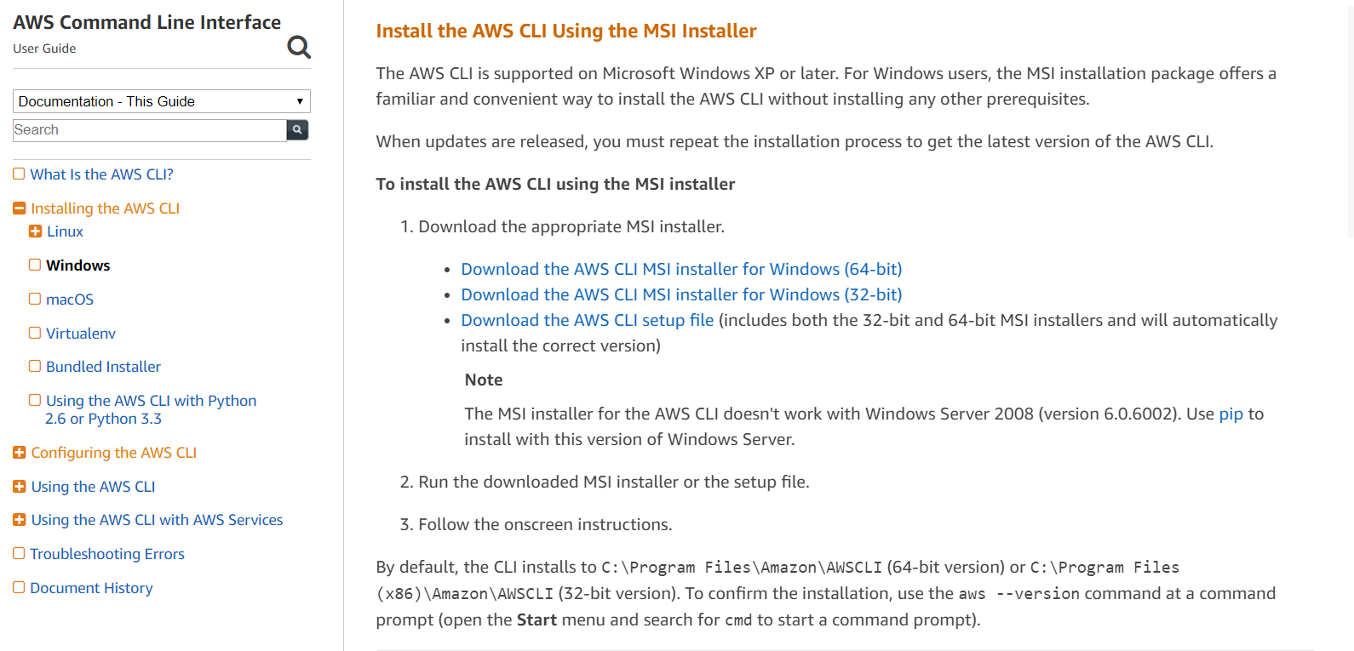

Like below a file will be downloaded and it need to RUN and setup.



**Set up the environmental Variable:**

* Search for “View Advanced System Setting”
* Go to Environmental Variable
* Click on the Path variable and Edit
* Click new and add the Path of the AWSCLI bin directory and Click ok to set.

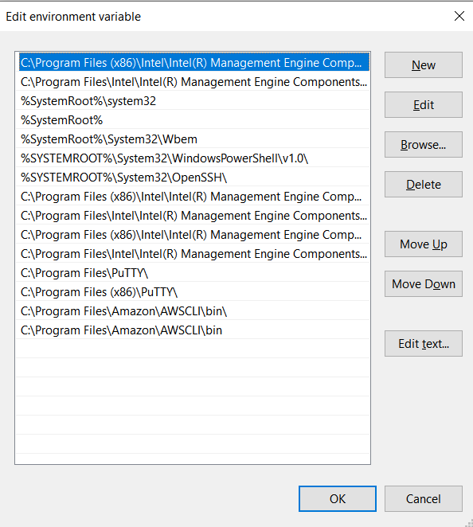

* Verify from the command line as below,

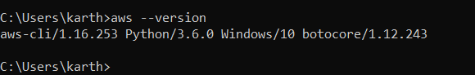

**Configuring the AWS CLI:**

Create an IAM user with full Administrative access and keep ready the Access key & Secret key.

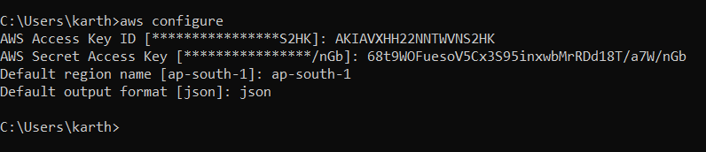

**Export VM from its Current Env as an OVA File:**

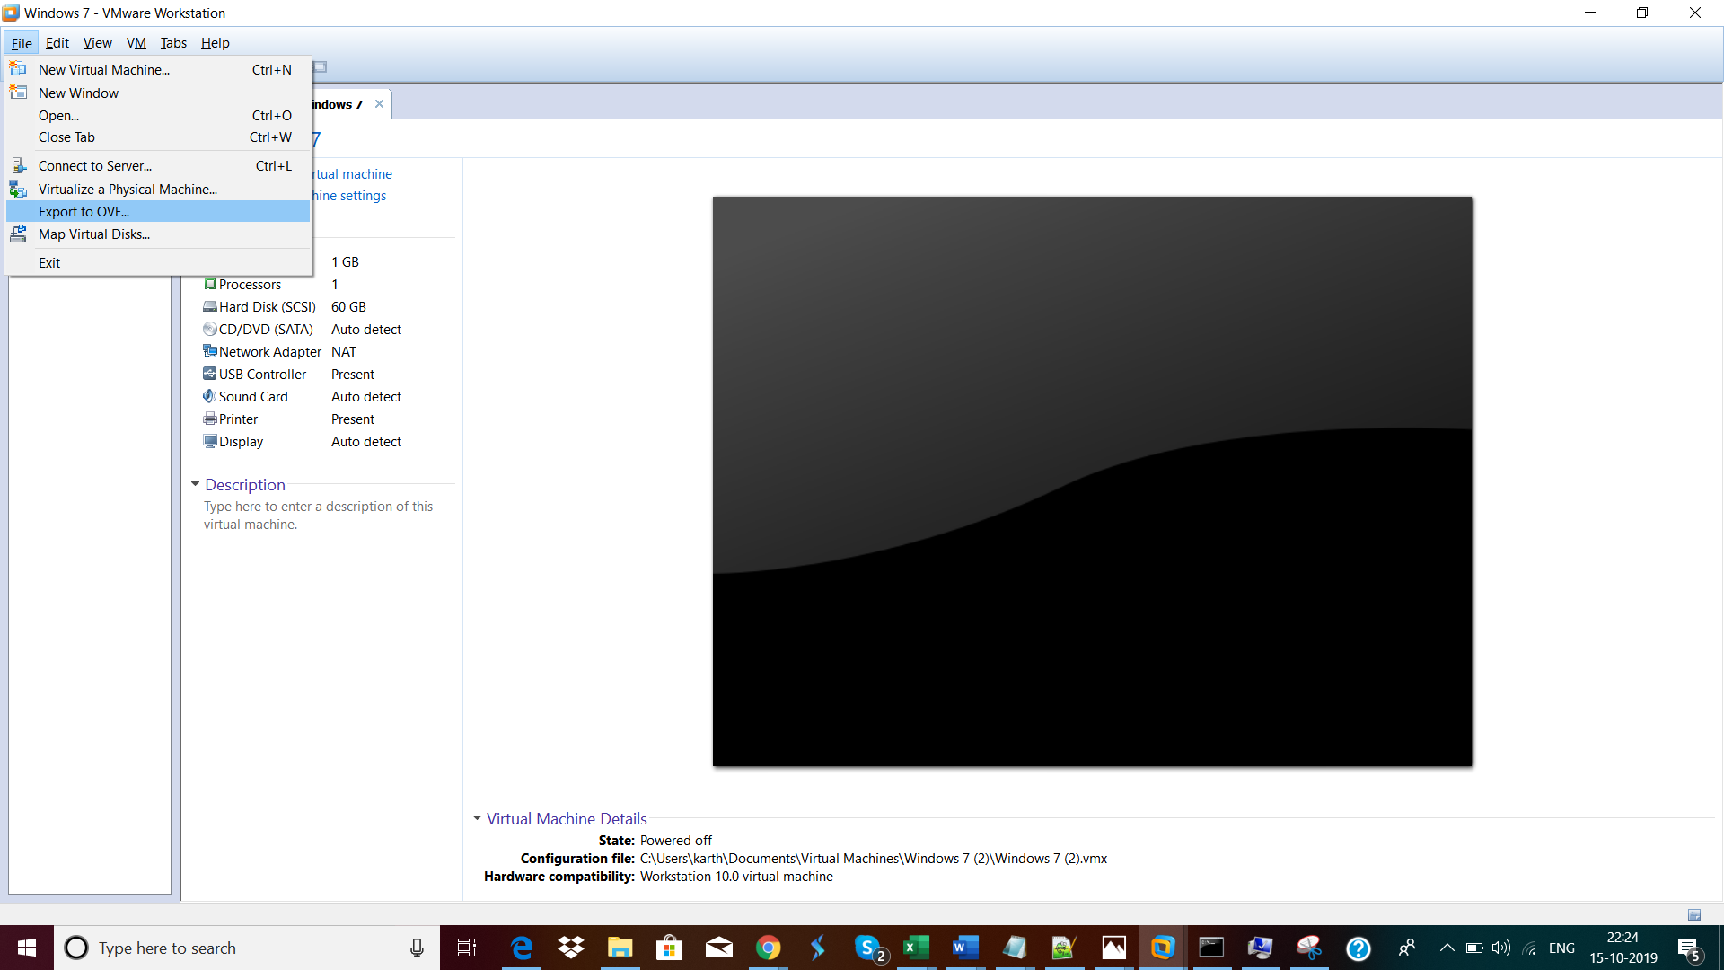

Save as .ova file in the local machine, like below.

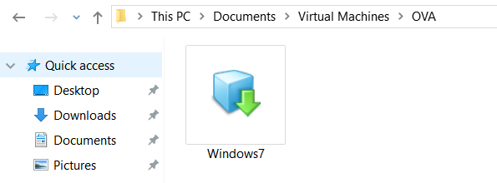

**Create a S3 bucket & upload the VM Image:**

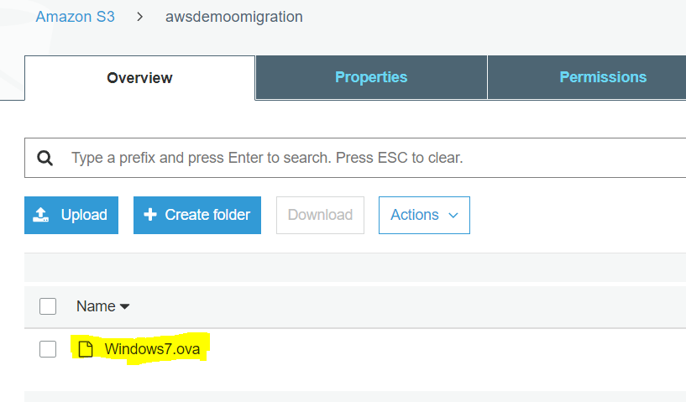

**VMImport – VM Import Service Role:**

Refer the below link,

<https://docs.aws.amazon.com/vm-import/latest/userguide/vmie_prereqs.html#vmimport-role>

1. Create a file named trust-policy.json on your computer. Add the following policy to the file.



1. Create-role command to create a role as vmimport & grant VM Import/Export access to it.

*aws iam create-role --role-name vmimport --assume-role-policy-document "file://C:/Users/karth/Documents/AWS/Notes/AWS+Migration/trust-policy.json"*

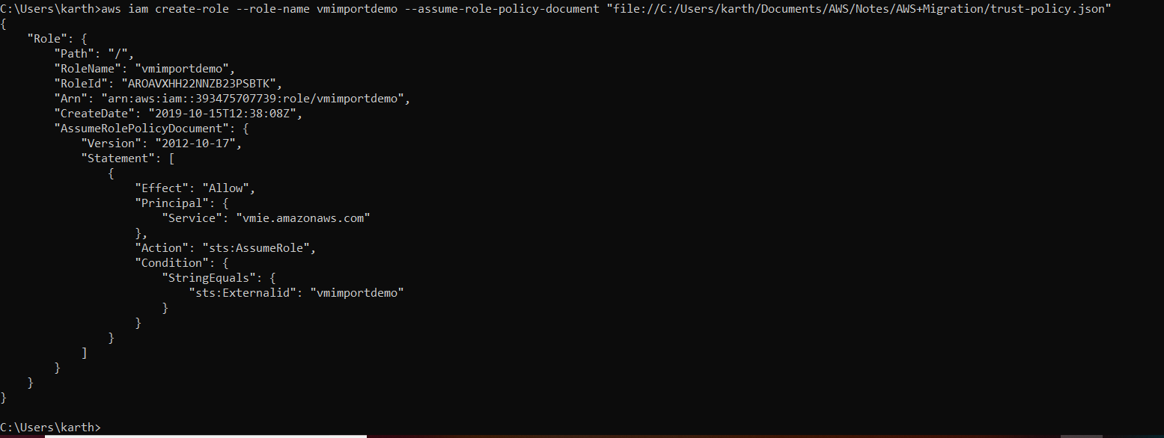

1. Create a file named role-policy.json with the following policy.



1. Use the following put-role-policy command to attach the policy to the role created above.

*aws iam put-role-policy --role-name vmimport --policy-name vmimport --policy-document "file://C:/Users/karth/Documents/AWS/Notes/AWS+Migration/role-policy.json"*



1. Create a file named containers.json.



1. Import the OVA image. Refer the below URL, from **Import the VM**

<https://docs.aws.amazon.com/vm-import/latest/userguide/vmimport-image-import.html>

*aws ec2 import-image --description "Windows 7 ova" --disk-containers "file://C:/Users/karth/Documents/AWS/Notes/AWS+Migration/containers.json"*

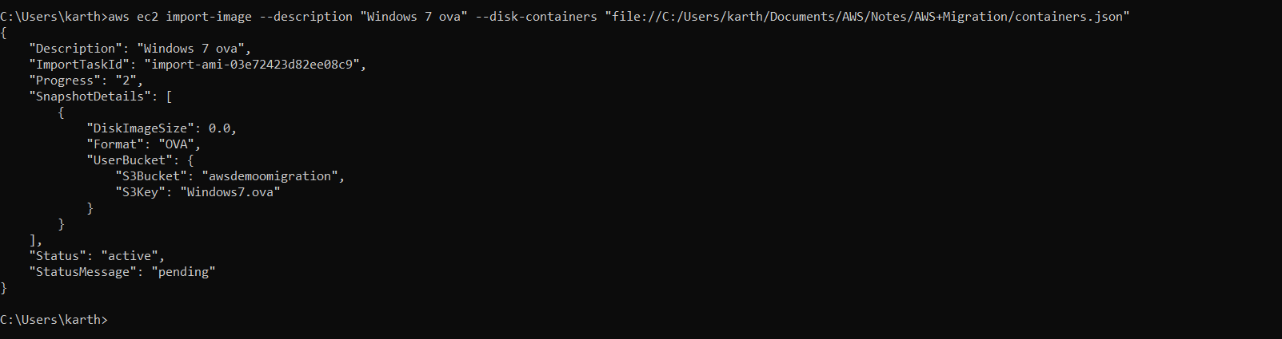

1. Once the Import-Image is done, check the status using the below command,

*aws ec2 describe-import-image-tasks --import-task-ids import-ami-03e72423d82ee08c9*

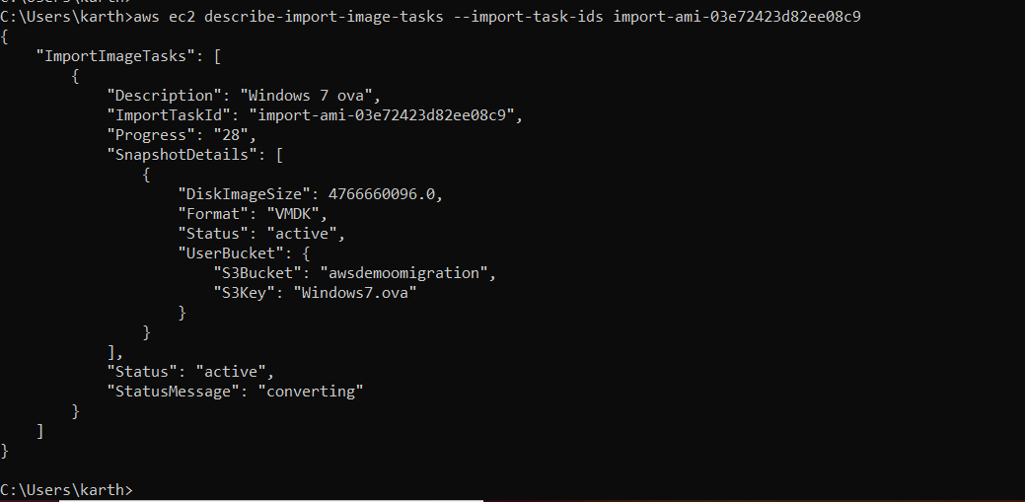

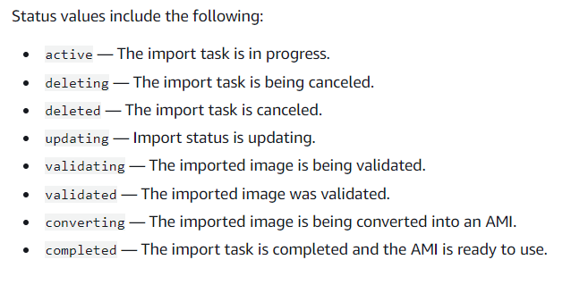

1. Different status will be updating, like the below screenshots,

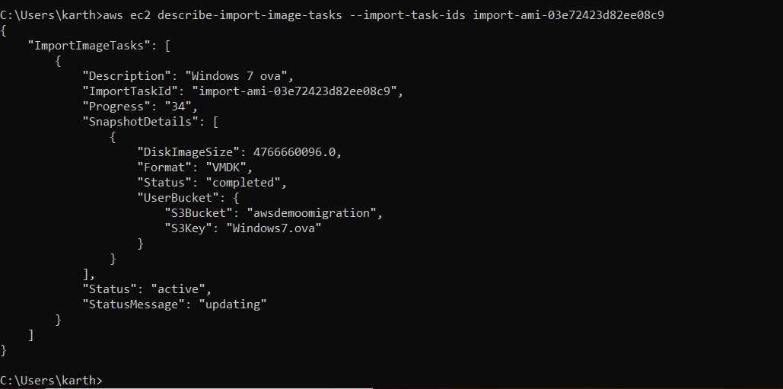

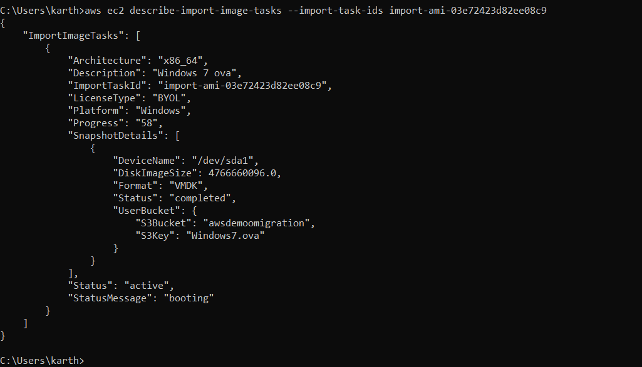

1. Finally Completed, Then go check the AMI under the EC2, new AMI will be available.

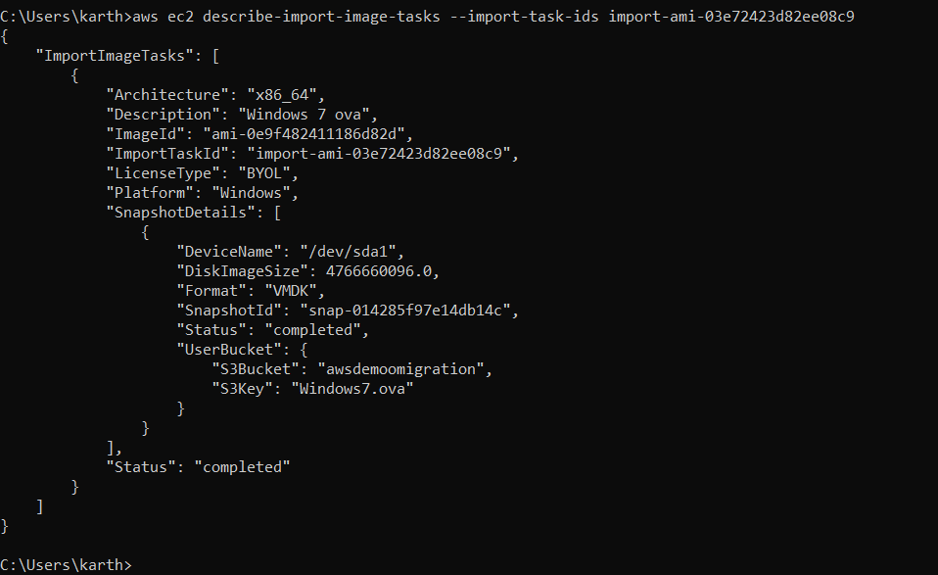

**Use the Below AMI and Create a Cloud Premises EC2 instance.**

